|  |  |
| --- | --- |
| Application Title Goes Here  Subtitle goes here | This document is meant to assist developers in understanding the application needs and expectations from the business perspective as well as a design prospective  Author Name  author@email.com  Author Title |

Contents

Introduction 1

Application Data Objects & Definitions (Schema Core DDL) 1

Application ERD 2

Application Actors & Functions 3

Identified Workflow(s) 3

Application Scopes Based on User Roles 3

Automations / Integrations / Synchronization 5

Reporting 5

Report: IT SPEND – Power BI Mockup 6

Additional Considerations - BUG/Missing Feature avoidance. 7

# Introduction

The primary function and goal of this application is…

How the application achieves the goal is by…

The general expectations are...

**Specific Nomenclature, abbreviations**, all go here and tell the reader.

# Application Data Objects & Definitions (Schema Core DDL)

1. *Table Name A* – What is the purpose of this table and how does it support the application.
2. *Table Name B* – What is the purpose of this table and how does it support the application.
3. *Table Name C* – What is the purpose of this table and how does it support the application.
4. *Table Name D* – What is the purpose of this table and how does it support the application.

# Application ERD

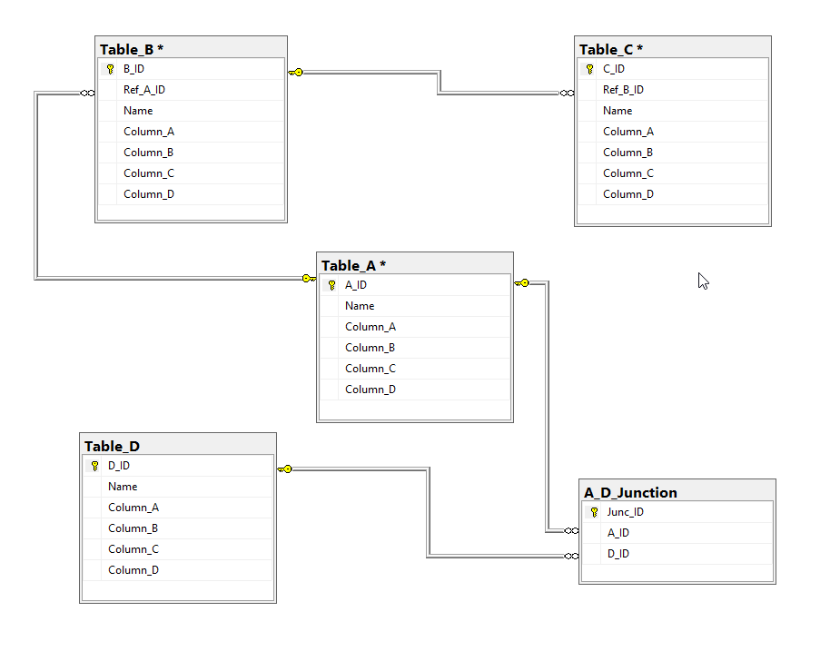

# Application Actors & Functions

This application will have the following actors and their function:  
*Actors play a role in the business and naming is either equal to their title or their role they will play in a particular process that the application supports. There is no hard and fast rule here, but the key is listening to the product owner on the business side*

* *Initiator* – Any person responsible for kicking off the process
* *Auditor* – A person responsible for monitoring compliance
* *Manager of Auditor* – A person who holds the most accountability regarding audits
* *Buyer* – a person who monitors inventory levels and is responsible for purchasing
* *Financer* – An external entity who will pay for goods purchased by this company

# Identified Workflow(s)

*I may be good to structure this portion of the document with subtitles if you have more than one parent workflow process to share. You should cover all the use cases.*

1. This is a vision diagram in word form. This line item would normally represent the START of the workflow process.
2. Next step in the process here
3. The next one
4. Final step here with expected result…

# Application Scopes Based on User Roles

*Here you want to break down the sections of the app and relate them to the actors and describe who will be accessing what areas and what those areas will do.*

The application Actors will fall into these **roles**:

1. Private users Initiators are part of department xxx (application access restricted)
2. Managers of the User (may or may not be in the same department but still need access). Managers need to approve users actions.
3. Approvals and auditing summary dahboards meant to communicate status and allow auditors easy access to change granular details of data as they relate to inventory and or purchases.

Security around application screens need to consider these roles when allowing access to areas of the application.



# Automations / Integrations / Synchronization

The following are a list of currently known automations that need to be handled:

1. Automation A
2. Automation B
3. Integrations A
4. Synchronization of Y and Z

# Reporting

Describe what the user expects to get out of the system provide any samples as mockups.

**See next Page:**

## Report: IT SPEND – Power BI Mockup

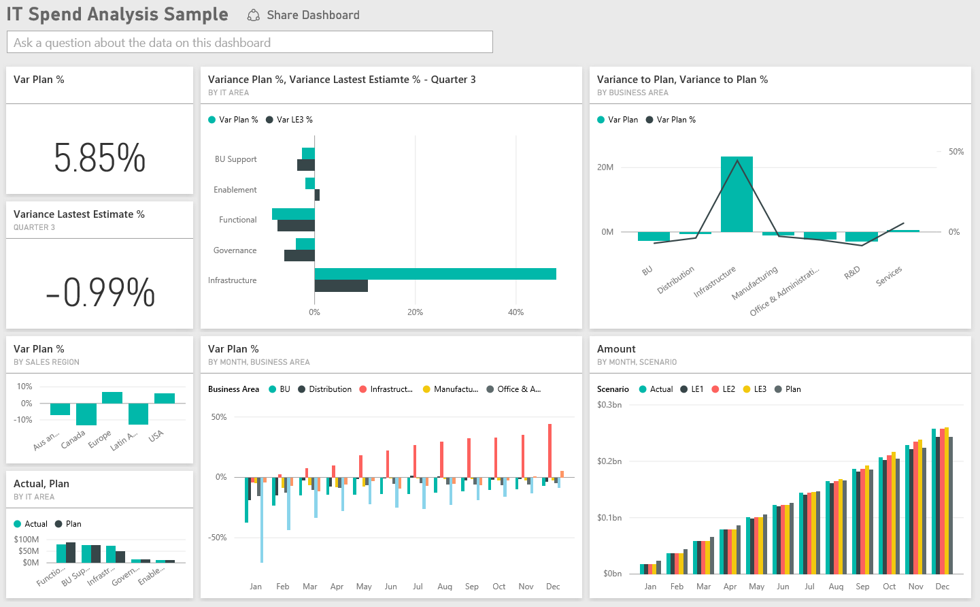

# Additional Considerations - BUG/Missing Feature avoidance.

* As you go through the process of documenting this all you may notice things that may cause or be issues later. This is where you document EACH observation as a point of RISK. Which can then be used later for risk avoidance and or by developers ensuring reusability in a particular area is HIGHLY flexible.

Summary statements go here